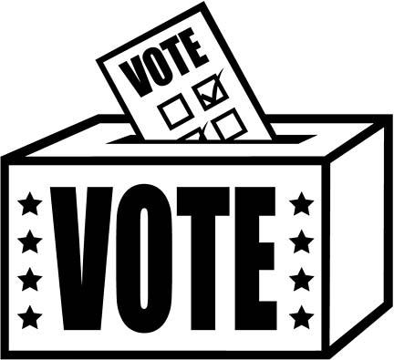

AP United States Government
Unit 3 Calendar:
Voting Behavior and Interest Groups

Date | Assignments Due  Assessments | In-Class | Homework/Reading Assignment
Monday  10/8 |  | Columbus Day No School | Read and Complete Ch. 9.1
Tuesday  10/9 |  | Chapter 9.1  Primaries and Caucus | Read and Complete Ch. 9.2
Wednesday  10/10 |  | Finish Chapter 9.1 & 9.2 | Read and Complete Ch. 9.3
Thursday  10/11 |  | Chapter 9.3  PAC’s | Read and Complete Ch. 9.4
Friday  10/12 |  | Chapter 9.4  Chapter 9.5 Who Votes | Read and Complete Ch.9.5
Monday  10/15 |  | Chapter 9.6 & 9.7  How Americans Votes | Read and Complete Ch.9.6
Tuesday  10/16 |  | Chapter 9.8  Electoral College Web quest | Read and Complete Ch. 9.7
Wednesday  10/17 |  | Finish WebQuest | Read and Complete Ch. 9.8
Thursday  10/18 | Ch. 8 & 9 Quiz  Ch. 9 Outline Due | Chapter 8 & 9 Quiz  Practice FRQ | Relax
Friday  10/19 |  | Introduce Interest Groups | Read and Complete Ch. 10.1
Monday  10/22 |  | Interest Groups and Policymaking | Read and Complete Ch. 10.2
Tuesday  10/23 |  | Iron Triangle | Read and Complete Ch. 10.3
Wednesday  10/24 |  | Types of Interest Groups | Read and Complete Ch.10.4
Thursday  10/25 |  | Interest Groups Continued | Read and Complete  Ch. 10.5 & 10.6
Friday  10/26 | Chapter 10 Outline | NRA | Study!
Monday  10/29 |  | Interest Group WebQuest | Study!
Tuesday  10/30 |  | Finish WebQuest | Study!
Wednesday  10/31 |  | Review | Study!
Thursday  11/1 | Unit 3 FRQ | Unit 3 Exam FRQ | Study!
Friday  11/2 | Unit 3 EXAM  Notebook Check | Unit 3 Exam MC | Read and Complete Ch.12.1

