AP United States Government
2018 - 2019
Unit 2 Calendar:
Political Beliefs and Behavior
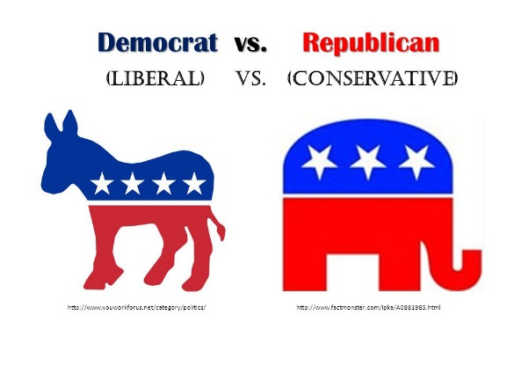

Date | Assignments Due  Assessments | In-Class | Homework/Reading Assignment
Monday  9/10 |  | Chapter 6.1 | Read and Complete Ch. 6.1
Tuesday  9/11 |  | Chapter 6.2  Yertle to Turtle | Read and Complete Ch. 6.2
Wednesday  9/12 |  | Finish Chapter 6.2 | Read and Complete Ch. 6.3
Thursday  9/13 |  | Chapter 6.3  Polling & Literary Digest Polls | Read and Complete Ch. 6.4
Friday  9/14 |  | Chapter 6.4  What are your Political Views | Read and Complete Ch. 6.5
Monday  9/17 | Chapter 6 Outline Due | Chapter 6.5  Voter Participation | Finish Chapter 6 Outline
Tuesday  9/18 |  | Chapter 7.1 & 7.2  Why is the Media Important/Obama on Letterman | Read & Complete Ch. 7.1 & 7.2
Wednesday  9/19 |  | Kennedy v. Nixon Debate  Practice FRQ | How do you like you news – Hard or Soft?
Thursday  9/20 |  | Chapter 7.3 & 7.4  Bias in the Media | Read & Complete Ch. 7.3 & 7.4
Friday  9/21 |  | Chapter 7.5 & 7.6  Agenda Setting | Read & Complete Ch. 7.5 & 7.6
Monday*  9/24 | Ch. 6 & 7 Quiz  Ch. 7 Outline Due | Chapter 8.1  The Downs Model | Read and Complete  Ch. 8.1 & 8.2
Tuesday  9/25 |  | Chapter 8.2 & 8.3 | Read and Complete  Ch. 8.3 & 8.4
Wednesday  9/26 |  | Chapter 8.4 | Read and Complete Ch.8.5
Thursday  9/27 |  | Chapter 8.5  Party Era’s | Read and Complete  Ch.8.6 & 8.7
Friday  9/28 |  | Chapters 8.6 & 8.7  3rd Parties and Barriers | Study!
Monday  10/1 |  | FLEX DAY | Study!
Tuesday  10/2 | How do you like your news? | REVIEW | Study!
Wednesday  10/3 |  | Unit 2 Exam (FRQ) | Study!
Thursday  10/4 | Chapter 8 & Binder Check | Unit 2 Exam (MC) | Read and Complete Ch. 9.1
Friday  10/5 |  | No School – Teacher Workday

