AP United States Government
Unit 4 Calendar:
President and Bureaucracies
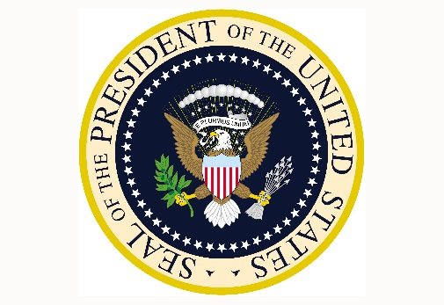

Date | Assignments Due  Assessments | In-Class | Homework/Reading Assignment
Monday  11/12 |  | War Power and POTUS in Check | Read and Complete Ch. 12.5
Tuesday  11/13 |  | Our new normal  Review and FRQ | Read and Completer Ch.12.6
Wednesday  11/14 |  | Review and FRQ | Read and Complete  Ch. 12.7 & 12.8
Thursday  11/15 |  | Work on you POTUS Report card | Finish you POTUS Project
Friday  12/16 | POTUS Rep. Card!  Ch. 12 Outline | Work on your Chapter 14 Outline | Read and Complete Ch. 14. 1
11/19 to 11/23 Thanksgiving Break NO SCHOOL

Monday  11/26 |  | Review and FRQ | Read and Complete Ch. 14.2
Tuesday  11/27 |  | Bureaucracy Info Graphic  Review POTUS | Read and Completer Ch.14.3
Wednesday  11/28 |  | Notes 14. 1 – 14.3  Cabinet and Agency Classifications | Read and Complete Ch.14.4
Thursday  11/29 |  | Student Organizer 1-3 | Read and Complete Ch. 14. 4
Friday  11/30 |  | Notes 14.4  Regulation v Deregulation | Read and Complete Ch. 14. 5
Monday  12/3 |  | Finish lesson on Bureaucracy | Read and Complete Ch. 14.5
Tuesday  12/4 |  | Bureaucracy of Pizza | Infographic & Study!
Wednesday  12/5 | Chapter 14 Outline Due | Review and FRQ | Infographic & Study!
Thursday  12/6 |  | Review and FRQ | Study!
Friday  12/7 | Vocab & Reading  Quiz Ch. 12 & 14 | How would you turn a law into Government Regulation? | Study!
Monday  12/10 | Final Exam FRQ | Final Exam FRQ! | Infographic & Study!
Tuesday  12/11 |  | Review | Infographic & Study!
Wednesday  12/12 |  | Review | Infographic & Study!
Thursday  12/13 |  | Review | Infographic & Study!
Friday  12/14 | Infographic  Due | Review | Study!
Monday  12/17 | Finals Week | 1st Period Final | Study!
Tuesday  12/18 | Finals Week | Exam Schedule 3rd and 6th | Study!
Wednesday  12/19 | Finals Week | Exam Schedule 4th and 2nd | Study!
Thursday  12/20 | Finals Week | Exam Schedule 5th and 7th | Study
Friday  12/21 |  | ENJOY YOUR BREAK! | See you in 2019!

